**SM3601 Licensed Game Design**

**Game Concept**

Game Name: Escape from Jedi!!

Genre: Action

Player Objective: Go to the exit within a time

Feature:

This game is a third-person view action with great 3D modeling. All the characters are from the famous movie, Star Wars. Player need to use their strategy and skills to achieve the goal.

**References**

**Star Wars** is an American epic space opera franchise, centered on a film series created by George Lucas. It depicts the adventures of various characters "a long time ago in a galaxy far, far away".

The first film in the series, Star Wars (later subtitled Episode IV: A New Hope), was released on May 25, 1977 by 20th Century Fox and became a worldwide pop culture phenomenon. It was followed by the similarly successful sequels The Empire Strikes Back (1980) and Return of the Jedi (1983); these three films constitute the original Star Wars trilogy. A prequel trilogy was later released between 1999 and 2005, which received a more mixed reaction from critics and fans, compared to the original trilogy. All seven films were nominated for or won Academy Awards, and were commercial successes, with a combined box office revenue of $4.38 billion, making Star Wars the fourth highest-grossing film series. The series has spawned an extensive media franchise—the Star Wars expanded universe—including books, television series, computer and video games, and comic books, resulting in significant development of the series's fictional universe. Star Wars also holds a Guinness World Records title for the "Most successful film merchandising franchise." In 2012, the total value of the Star Wars franchise was estimated at USD $30.7 billion, including box-office receipts as well as profits from their video games and DVD sales.

In 2012, The Walt Disney Company acquired Lucasfilm for $4.06 billion and announced three new Star Wars films; the first film of that trilogy, Star Wars: The Force Awakens, was released on December 18, 2015. 20th Century Fox retains the physical distribution rights to the first two Star Wars trilogies, owning permanent rights for the original 1977 film and holding the rights to Episodes I–III, V and VI until May 2020. The Walt Disney Studios owns digital distribution rights to all the Star Wars films, excluding A New Hope.

**Market**

Similar Game:

Assassin Script – third-person and action game

Star Wars Battlefront – third-person and action game

Target Buyer: Star Wars Fans, People who like action game

System Requirements:

Platform: Window, OSX

CPU: Intel Core i5-6400 Processor (6M Cache)

RAM: 4GB

Hard disk Space: 20GB

**Game Story**

[The game story is based on the Star Wars movie. However, Players are not act as the Jedi, they act as one of the robot solider from dark side.]

You are one of the robot solider from dark side and our AI is different from the other robot solider. You receive an order that to defend the stronghold to the last. However, you know that the opposite Jedi are coming and you have no chance to win the war. As a result, you are now planning for escape from the Jedi.

**Game Play Description**

This is a third-person view game. You need to follow the game instruction and control your character to achieve your goal. There are few of the components in the game:

HP: Health Point

Energy: used for ‘Running’. It will recover automatically

Suspicion: If you leave the eye from the other robot solider for a long time or doing some unusual action (e.g. don’t help while they are fighting), they will they will attack you.

Item: Showing what you are using

Map: Showing the

1. terrain

2. positioning of the other robot soldier

3. Events (e.g. Fighting)

**Game Screen**

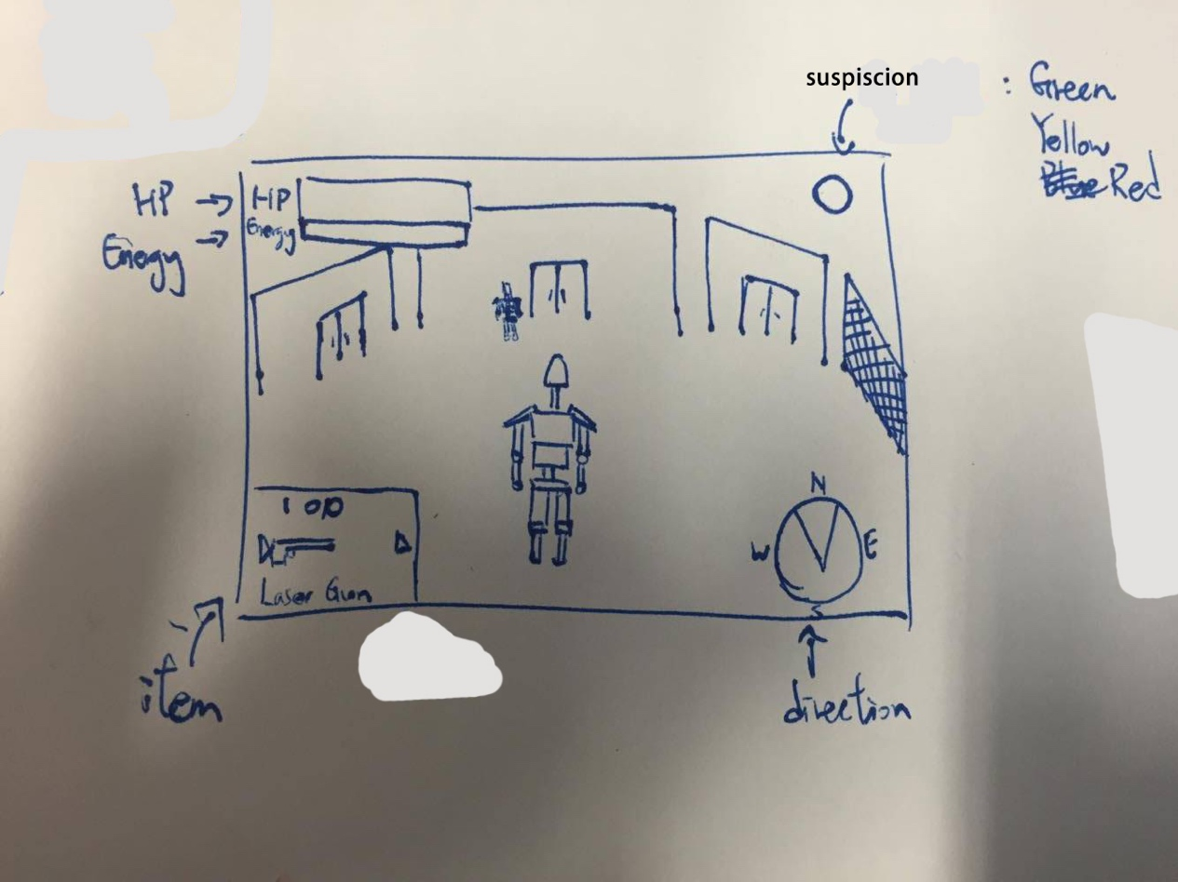

**Map**

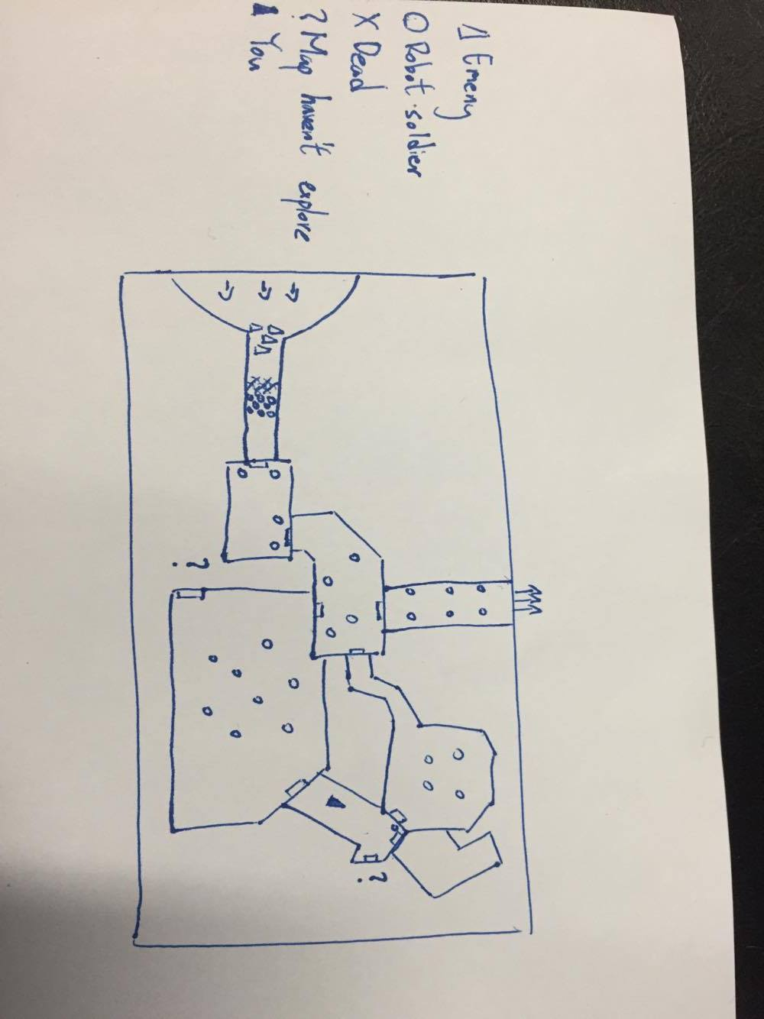

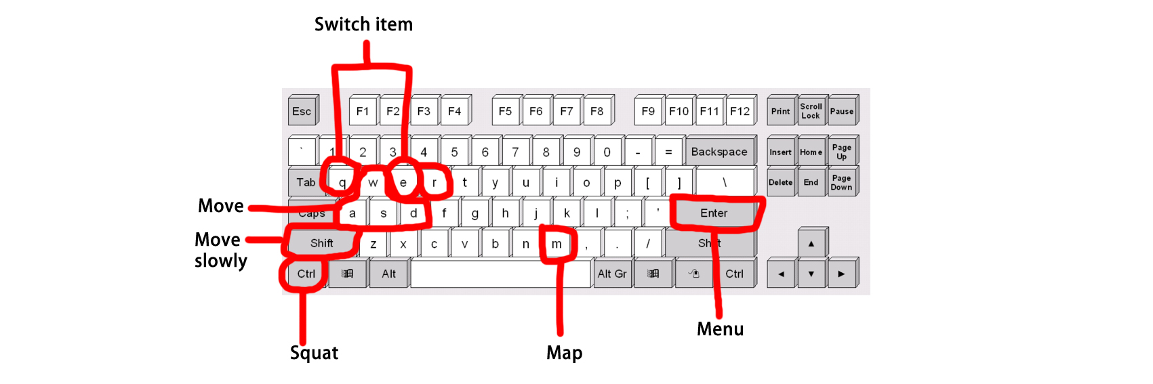**Game Control Diagram**